Program Manager
Version 1.0

Thomas Pologruto
March 4, 2004
© 2004 HHMI/Cold Spring Harbor Labs

Introduction

The Program Manager is a MATLAB class (@progmanager) used for creating Graphical User Interface (GUI) based MATLAB applications. The per se "Programs" used in the Program Manager are from the MATLAB program class (@program) and consist of any number of GUIs that can each be customized by the programmer. The central purpose of the program manager class is to reduce the amount of programming for the user, and improve the readability and reusability of the code generated. GUIs can be used multiple times in same program or in many different programs many times.

The MATLAB "programs " are of class program and are really containers for the GUIs. Each GUI is expected to have an m-file and fig-file somewhere on a valid MATLAB path, usually generated through GUIDE (see GUI Design below for details). Please see the MATLAB help on setting the search path for details.

A program object is constructed using the program function (which is the constructor for the program class if that means anything to you, and don't worry if it does not). The first input to the function is the name of the program. The name must not have any white spaces or funny characters, but '_' are acceptable. The rest of the inputs are parameter/value pairs. The first input (parameter) is the alias for the GUI in the program (can be different than the m-file name of the GUI) and must follow the same naming rules as the program name. The second input (value) is the name of the m-file/fig-file of the GUI. The output of the program function is a program object that can be assigned to a variable (e.g. program_object). The program can be loaded by calling openprogram(progmanager,program_object)and once opened can be saved from the GUI to disk. The filename will have a .pmp extension, and it can be opened by the program manager to load the program again without having to construct another program object each time.

Once a program object is defined, another one need not be created for the same program, unless GUIs or added or names are changed. If variables, window positions, etc… are changed in the program, these different changes can be saved into another (or the same) .pmp file and loaded at another time. In this way, the program manager will capture all the details of the current state of the program without the user having to do any additional configuring.

The main function for displaying the program manager browser that enables selection of programs to be loaded from disk is called progmanagerdisp that needs to be called with the progmanager object as the input (i.e. call progmanagerdisp(progmanager) on the command line). This function opens a GUI where currently running programs are displayed, new programs can be opened, and where program manager properties can be changed.

GUI Design

GUIs are designed using the current version of GUIDE, which can be accessed by typing guide at the command line. The following guidelines need to be adhered to when writing GUIs for use with the program manager.

Guidelines for GUI Construction

- Each and every uicontrol object (e.g. pushbutton, checkbox, editbox, etc…) or axes placed in the GUI needs to have a valid Tag property associated with it.
  - The Tag is a string (no white spaces or funny characters, but '_'are OK) of any length that will uniquely identify the object to the program manager and to MATLAB.
  - You can change the Tag or any other property of the GUI by doubling clicking on it to bring up the Property Inspector.
    - Once the property inspector is initiated, a single click on a uicontrol will update the inspector with the parameters from that object.
  - You should also assign a TooltipString as well as a String to the uicontrol in GUIDE. The TooltipString is the text that will appear when the mouse rests on the uicontrol object, while the String is the word that will appear on the uicontrol object.
    - N.B. Strings should not be defined for edit boxes.

- Once the GUI is laid out correctly and all the uicontrol fields are filled in, save the setup.
  - GUIDE will create the fig-file and generate an m-file with the same name and save them in the same directory (which you select) with the filename you input. Let's assume the names of the m-file/fig-file are newGUI.m and newGUI.fig.
    - Note that 'newGUI' (not 'newGUI.m' or 'newGUI.fig') is name is the GUI name (the "value" in the param/value pairs) used in constructing a program object in the program function.

- Open and edit the generated m-file. If the file is saved somewhere on the MATLAB path, typing edit newGUI on the command line opens the m-file edit window (if GUIDE did not already open it when you saved the GUI). This file needs to have the following done to it:
  - Remove any documentation lines from the m-file (green lines which are prefixed by an %) that are unnecessary (and most of them are superfluous). All of the green lines (except the ones at the very top) can be deleted from the m-file. This will enhance readability.
  - For example, take the following code which is generate when a single edit box with tag newControl:

% --- Executes during object creation, after setting all properties.
function newControl_CreateFcn(hObject, eventdata, handles)
% hObject handle to newControl (see GCBO)
% eventdata reserved - to be defined in a future version of MATLAB
% handles empty - handles not created until after all CreateFcns called

% Hint: edit controls usually have a white background on Windows.
% See ISPC and COMPUTER.
if ispc
set(hObject,'BackgroundColor','white');
else
set(hObject,'BackgroundColor',get(0,'defaultUicontrolBackgroundColor'));
end

function newControl_Callback(hObject, eventdata, handles)
% hObject handle to newControl (see GCBO)
% eventdata reserved - to be defined in a future version of MATLAB
% handles structure with handles and user data (see GUIDATA)

% Hints: get(hObject,'String') returns contents of fineMovementAmount as text
% str2double(get(hObject,'String')) returns contents of fineMovementAmount % as a double

The code should be changed to:

%%%%%%%%%%%%%%%%%%%%%%%%%%%%%%%%%%%%%%%%%%%%%%%%%%%%%%%%%%%%%%%%%
function newControl_CreateFcn(hObject, eventdata, handles)
if ispc
set(hObject,'BackgroundColor','white');
else
set(hObject,'BackgroundColor',get(0,'defaultUicontrolBackgroundColor'));
end

%%%%%%%%%%%%%%%%%%%%%%%%%%%%%%%%%%%%%%%%%%%%%%%%%%%%%%%%%%%%%%%%%
function newControl_Callback(hObject, eventdata, handles)

in the final saved form of the m-file.

  - Change the green commented lines at the top of the file to describe what the program does, how to use it, etc…
    - This is important, because when the user of the program selects help from the GUI, this is what they will see in the help browser.
  - Add the following functions (can cut and paste from here) to the bottom of the m-file using this syntax:

function out=makeGlobalCellArray(fig_handle,eventdata,handles)

function genericStartFcn(fig_handle,eventdata,handles)

function genericUpdateFcn(fig_handle,eventdata,handles)

function out=getVersion(fig_handle,eventdata,handles)

  - Resave the m-file.

- Configure variables used in the GUI by writing the cell array into the makeGlobalCellArray function you just added to your GUI.
  - The makeGlobalCellArray function is the key function that needs to execute. It will tie the variables in the GUI to the GUI controls, and will also register those variables with the program manager.
  - The output of the makeGlobalCellArray function outputs a cell array with the following format:
    - 1st element is the string name of the first variable you are initializing, and the 2nd element is the value you would like this variable to be initialized to. The value can be any valid MATLAB expression.
    - Following the variable and its initial value, parameter/value pairs describing that variable are input.
      - Valid param/values:
        - 'Class' : 'double', 'bool', 'int', 'char'
        - 'Gui' : 'nameofguihandle'
        - 'Min': number
        - 'Max': number
        - 'Config': number
      - Type help parseGlobalCellArray for more details.
    - The program knows to stop parsing the param/value pairs for that variable when it reads the next variable name.
  - The variables included in the makeGlobalCellArray, and in particular the ones tied to a GUI uicontrol object, will be managed by the program manager. When the GUI is changed the variable will reflect that change, and vice versa. No additional code is necessary for this action to be accomplished, even in the object's callback (which is in the m-file for the GUI).
    - Use getlocal/setlocal to change these variables in the code.
    - Use getlocalgh/setlocalgh to change the uicontrol objects during the program.
  - The easiest way to write it is shown in the example below.

The Big Example: Writing a GUI to browse Image objects currently in the MATLAB workspace.

Idea: We would like a GUI that will have a small axis on which any image that is currently in the MATLAB workspace can be displayed. We would like to be able to select the image to display based on its tag or handle via a listbox interface.

Design: The program manager will allow the user to assign variables to GUI uicontrol objects, like edit boxes, sliders, checkboxes, etc… These variables are updated when the GUI is changed by the user, and vice-versa the GUIs are updated when the variables are changed. In this way, the programmer can tie one variable to any number of uicontrols, although by design usually all the uicontrols for one variable will lie on the same GUI. All the variables are accessible to all callbacks for all uicontrols, so data sharing is greatly simplified.

GUIDE Layout

GUIDE can be started by typing guide from the command line and opening a Blank GUI:

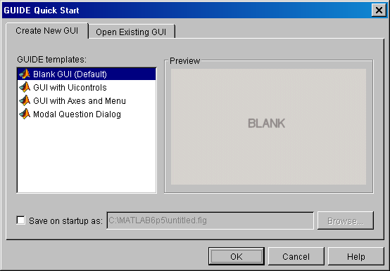
Please layout the GUI so it resembles to following:

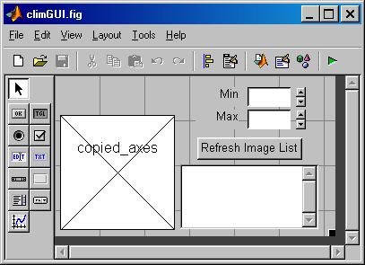

After each object is laid out, assign tags to each object by double clicking on it to bring up the property editor for that object. In the property editor, you can select and edit the properties of all the GUI objects, including the figure and axes. Here we double-clicked on the edit box next to the word Min to bring up the property editor for that uicontrol object (see below). The Tag property and TooltipString property should be set at this time.

As a convention, the Tag of the edit box that will display a variable used in the program should have the same name as that variable. This makes it easier to remember which variable is tied to which uicontrol. This is important, since many uicontrols can be tied to one variable, although the opposite is not true: many variables cannot be assigned to the same uicontrol.

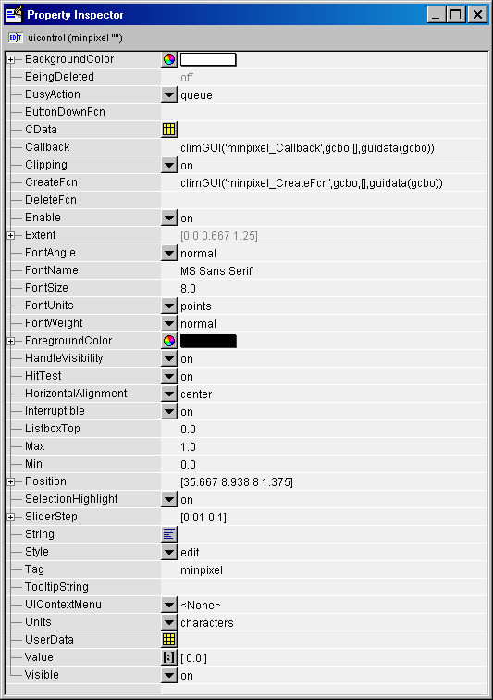

For example, the variable in the GUI is called minpixel, and the Tag of the edit box is also called minpixel. I would also like a slider control linked to the same variable, so I will set the Tag for the slider to minpixelSlider. This is another useful convention. Other uicontrols tied to a variable will have the style of uicontrol (slider, listbox, etc…) appended to the name of the variable. Of course, if only one uicontrol is tied to a variable, then it should simply have the same Tag as the name of the variable it is controlling, regardless of the style. As a general rule, static text boxes do not have variables tied to them, and assigning them valid Tags is at the discretion of the programmer.

Below is the GUI as designed, with the Tag names laid on top of the various uicontrols. Notice that any axes that you put in the GUI will have its Tag already placed in the axes center (see copied_axes below).

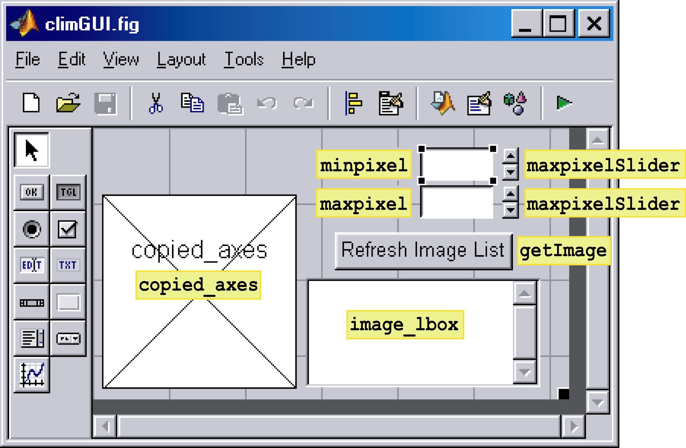

Other tips for GUI layout using GUIDE:

- Commands like Ctrl+A for selecting all components works in GUIDE, and can be used to set multiple object properties at the same time.
- It is easier to design things with their Units property set to pixels (especially axes), but when you are done laying everything out, switch all the Units to Character. This will prevent the GUI from becoming misshapen when opened on different screen resolutions.
- Use the Alignment Button for making objects line up or distributed evenly.

M-File Editing and Saving

Once the GUI is setup, save it somewhere on a valid MATLAB path with the name climGUI. This will open the m-file (climGUI.m) that is generated along with the figure file (climGUI.fig). These two files are the only ones associated with the GUI.

The m-file consists of 2 basic parts: the MATLAB defined methods for handling the GUI, which usually comprise the top portion of the GUI, as well as the callbacks and create functions for each of the uicontrols in the GUI. DO NOT edit any of the code in the m-file (commented or not) below the help section describing the GUI and above the first callback or create function. This code is used by MATLAB when handling GUI callbacks, and is necessary to be in the m-file.

The section of un-editable code begins with the line % Begin initialization code - DO NOT EDIT and ends with % End initialization code - DO NOT EDIT. Pay attention to these warnings! The top most portion of the m-file has a large section of commented code with the m-file name already placed there, along with some generic comments. These lines can be replaced (should be replaced actually) with your own information about using the GUI. When help is called for your GUI, it is these lines of commented text that will be seen by the Help browser.

You should remove all the other comments placed in the callbacks and create functions as described above in this document. these can be replaced by lines of %%%%%%%%… to indicate the spacing between different functions. In addition, MATLAB allows you to jump to any of these functions (officially subfunctions) by using the button in the m-file editor (see below).

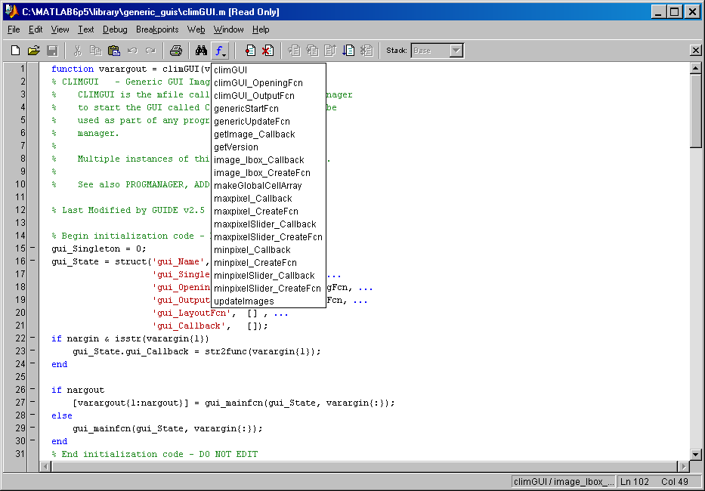

When you are done, the m-file should appear as follows:

function varargout = climGUI(varargin)
% CLIMGUI - Generic GUI Image Handle Browser.
% CLIMGUI is the mfile called from the program manager
% to start the GUI called CLIMGUI. This GUI can be
% used as part of any program in the program
% manager.
%
% Multiple instances of this GUI are also allowed.
%
% See also PROGMANAGER, ADDPROGRAM, STARTPROGRAM

% Last Modified by GUIDE v2.5 16-Feb-2004 11:16:43

% Begin initialization code - DO NOT EDIT
gui_Singleton = 0;
gui_State = struct('gui_Name', mfilename, ...
'gui_Singleton', gui_Singleton, ...
'gui_OpeningFcn', @climGUI_OpeningFcn, ...
'gui_OutputFcn', @climGUI_OutputFcn, ...
'gui_LayoutFcn', [] , ...
'gui_Callback', []);
if nargin & isstr(varargin{1})
gui_State.gui_Callback = str2func(varargin{1});
end

if nargout
[varargout{1:nargout}] = gui_mainfcn(gui_State, varargin{:});
else
gui_mainfcn(gui_State, varargin{:});
end
% End initialization code - DO NOT EDIT
%%%%%%%%%%%%%%%%%%%%%%%%%%%%%%%%%%%%%%%%%%%%%%%%%%%%%%%%%%%%%%%%%%%%%%%%%%%%%%%%%%%%%%%%%%%%%%%%%

%%%%%%%%%%%%%%%%%%%%%%%%%%%%%%%%%%%%%%%%%%%%%%%%%%%%%%%%%%%%%%%%%%%%%%%%%%%%%%%%%%%%%%%%%%%%%%%%%
function climGUI_OpeningFcn(hObject, eventdata, handles, varargin)
handles.output = hObject;
guidata(hObject, handles);

%%%%%%%%%%%%%%%%%%%%%%%%%%%%%%%%%%%%%%%%%%%%%%%%%%%%%%%%%%%%%%%%%%%%%%%%%%%%%%%%%%%%%%%%%%%%%%%%%
function varargout = climGUI_OutputFcn(hObject, eventdata, handles)
varargout{1} = handles.output;

%%%%%%%%%%%%%%%%%%%%%%%%%%%%%%%%%%%%%%%%%%%%%%%%%%%%%%%%%%%%%%%%%%%%%%%%%%%%%%%%%%%%%%%%%%%%%%%%%
function minpixel_CreateFcn(hObject, eventdata, handles)
if ispc
set(hObject,'BackgroundColor','white');
else
set(hObject,'BackgroundColor',get(0,'defaultUicontrolBackgroundColor'));
end

%%%%%%%%%%%%%%%%%%%%%%%%%%%%%%%%%%%%%%%%%%%%%%%%%%%%%%%%%%%%%%%%%%%%%%%%%%%%%%%%%%%%%%%%%%%%%%%%%
function minpixel_Callback(hObject, eventdata, handles)

%%%%%%%%%%%%%%%%%%%%%%%%%%%%%%%%%%%%%%%%%%%%%%%%%%%%%%%%%%%%%%%%%%%%%%%%%%%%%%%%%%%%%%%%%%%%%%%%%
function maxpixel_CreateFcn(hObject, eventdata, handles)
if ispc
set(hObject,'BackgroundColor','white');
else
set(hObject,'BackgroundColor',get(0,'defaultUicontrolBackgroundColor'));
end

%%%%%%%%%%%%%%%%%%%%%%%%%%%%%%%%%%%%%%%%%%%%%%%%%%%%%%%%%%%%%%%%%%%%%%%%%%%%%%%%%%%%%%%%%%%%%%%%%
function maxpixel_Callback(hObject, eventdata, handles)

%%%%%%%%%%%%%%%%%%%%%%%%%%%%%%%%%%%%%%%%%%%%%%%%%%%%%%%%%%%%%%%%%%%%%%%%%%%%%%%%%%%%%%%%%%%%%%%%%
function minpixelSlider_CreateFcn(hObject, eventdata, handles)
usewhitebg = 1;
if usewhitebg
set(hObject,'BackgroundColor',[.9 .9 .9]);
else
set(hObject,'BackgroundColor',get(0,'defaultUicontrolBackgroundColor'));
end

%%%%%%%%%%%%%%%%%%%%%%%%%%%%%%%%%%%%%%%%%%%%%%%%%%%%%%%%%%%%%%%%%%%%%%%%%%%%%%%%%%%%%%%%%%%%%%%%%
function minpixelSlider_Callback(hObject, eventdata, handles)

%%%%%%%%%%%%%%%%%%%%%%%%%%%%%%%%%%%%%%%%%%%%%%%%%%%%%%%%%%%%%%%%%%%%%%%%%%%%%%%%%%%%%%%%%%%%%%%%%
function maxpixelSlider_CreateFcn(hObject, eventdata, handles)
usewhitebg = 1;
if usewhitebg
set(hObject,'BackgroundColor',[.9 .9 .9]);
else
set(hObject,'BackgroundColor',get(0,'defaultUicontrolBackgroundColor'));
end

%%%%%%%%%%%%%%%%%%%%%%%%%%%%%%%%%%%%%%%%%%%%%%%%%%%%%%%%%%%%%%%%%%%%%%%%%%%%%%%%%%%%%%%%%%%%%%%%%
function maxpixelSlider_Callback(hObject, eventdata, handles)

%%%%%%%%%%%%%%%%%%%%%%%%%%%%%%%%%%%%%%%%%%%%%%%%%%%%%%%%%%%%%%%%%%%%%%%%%%%%%%%%%%%%%%%%%%%%%%%%%
function getImage_Callback(hObject, eventdata, handles)
updateImages(hObject);

%%%%%%%%%%%%%%%%%%%%%%%%%%%%%%%%%%%%%%%%%%%%%%%%%%%%%%%%%%%%%%%%%%%%%%%%%%%%%%%%%%%%%%%%%%%%%%%%%
function image_lbox_CreateFcn(hObject, eventdata, handles)
if ispc
set(hObject,'BackgroundColor','white');
else
set(hObject,'BackgroundColor',get(0,'defaultUicontrolBackgroundColor'));
end

Adding Necessary Functions to Use GUI in Program Manager

Once the m-file is formatted, we need to add the four sub-functions mentioned above. These functions are:

function out=makeGlobalCellArray(fig_handle,eventdata,handles)

function genericStartFcn(fig_handle,eventdata,handles)

function genericUpdateFcn(fig_handle,eventdata,handles)

function out=getVersion(fig_handle,eventdata,handles)

We shall look at these functions and describe them one at a time.

function out=makeGlobalCellArray(fig_handle,eventdata,handles)

makeGlobalCellArray is the function where variables are tied to uicontrol objects in the GUI. The output of this function (out) is a cell array of parameter/value pairs that are interpreted by the program manager to code the variables and uicontrols used in this GUI. Any variables that are tied to uicontrols or that you wish to be created and initialized to some value should go here. Variables defined in this function are initialized to the value set here.

Below we have made 3 variables and tied them to uicontrols in the GUI climGUI. The variables are minpixel, maxpixel, and image_lbox. Immediately following the name of the variable (separated by a comma as are all the entries in this function) is the value to initialize the variable with. This is all that is necessary to define a variable and initialize it, if we do not want to place any more functionality on that variable.

Here we are going to also define the 'Class' of the variable minpixel as a 'double', which means it is a double-precision number (positive or negative with any number of digits). Other possible 'Class' values are 'int' (integer number), 'char' (character or string which is not numeric), and 'bool' (numeric, but only allowed to be 1 or 0).

After we define the 'Class', we can list any uicontrols that are representing that variable. For minpixel and maxpixel, each has 2 uicontrols (one edit box and one slider) representing it. We tell the program manager to link these by specifying them by the parameter 'Gui' followed by the Tag of the uicontrol as defined in GUIDE. This is why it is important to specify Tags logically in GUIDE.

Following the 'Gui' definitions, we can then further specify a min and max value for the variable.

The finished function to be placed in the climGUI.m file is as follows:

%%%%%%%%%%%%%%%%%%%%%%%%%%%%%%%%%%%%%%%%%%%%%%%%%%%%%%%%%%%%%%%%%%%%%%%%%%%%%%%%%%%%%%%%%%%%%%%%%
function out=makeGlobalCellArray(fig_handle,eventdata,handles)
out={
'minpixel',0,'Class','double','Gui','minpixel','Gui','minpixelSlider','Min',15000,'Max',15000,...
'maxpixel',0,'Class','double','Gui','maxpixel','Gui','maxpixelSlider','Min',15000,'Max',15000,...
'image_lbox',1,'Class','int','Gui','image_lbox','Min',1,
};

function genericStartFcn(fig_handle,eventdata,handles)

genericStartFcn is the function that is called after the GUI is opened and all the variables are setup. This function can use variables defined in the makeGlobalCellArray function since they are created before this function is called. The purpose of genericStartFcn is to setup anything that cannot be initialized in the makeGlobalCellArray such as images and plots.
Functions using the program manager need to pass the program manager object to functions as the first parameter. This ensures the correct variables are updated when things are set. A local copy of the program manager object (an instance) can be obtained by calling progmanager and assigning the output to a variable. It is easiest if this is always the same variable, and that it is called at the top of the function.

Thus most functions begin with the line prog_manager_obj=progmanager where a copy of the program manager is stored in the variable prog_manager. This variable will be passed to functions like getlocal and setlocal, the two most useful functions in the program manager library.

getlocal and setlocal will get (set) values defined by variables defined in the GUI. The first input into these functions is the program manager reference, the second is either the figure handle of the GUI or the handle to one of the uicontrols (called hObject by MATLAB in the uicontrol callbacks), and the third is the name of the variable (a string). For getlocal , the fourth (optional) input are indices into the data stored in the variable, while for setlocal the fourth input is the value to set the variable to, followed by a fifth (optional) input to indices into the data stored in the variable where the assignment should be made.

Below is the genericStartFcn for the climGUI. The first line creates a local copy of the program manager object (called prog_manager_obj). The second line creates a new variable called 'currentimagedata' and initializes its value to zeros(128,128,1) (note that this could have been done in the makeGlobalCellArray function but was done here to illustrate using setlocal). The third line will set the variable called 'currentimagehandle' to the an image handle created from the data in 'currentimagedata' (gotten by calling getlocal(prog_manager_obj, fig_handle, 'currentimagehandle') ) and whose parent axes was set to the axes we defined in the climGUI using GUIDE with handle 'copied_axes' (gotten by calling getlocalgh(prog_manager_obj, fig_handle, 'copied_axes')).

We have now initialized our GUI with an image that we will update with other image handles and display on the axes we created.

%%%%%%%%%%%%%%%%%%%%%%%%%%%%%%%%%%%%%%%%%%%%%%%%%%%%%%%%%%%%%%%%%%%%%%%%%%%%%%%%%%%%%%%%%%%%%%%%%
function genericStartFcn(fig_handle,eventdata,handles)
% general function that sets up variables for this GUI. executed by the
% program manager after variables are assigned.

prog_manager_obj=progmanager; % reference to program manager

setlocal(prog_manager_obj,fig_handle,'currentimagedata',zeros(128,128,1));

setlocal(prog_manager_obj,fig_handle,'currentimagehandle',...
image(getlocal(prog_manager_obj,fig_handle,'currentimagedata'),...
'Parent',getlocalgh(prog_manager_obj,fig_handle,'copied_axes')));

function genericUpdateFcn(fig_handle,eventdata,handles)

genericUpdateFcn is the function that is called after the GUI is re-opened and all the variables are updated from a file saved on disk. This function can use variables defined in the makeGlobalCellArray function since they are updated before this function is called. The purpose of genericUpdateFcn is to re-setup anything that needs to be changed when variables saved in the GUI are changed when a saved program is loaded from disk.

We do not need a genericUpdateFcn here so we leave it blank (but still include it).

%%%%%%%%%%%%%%%%%%%%%%%%%%%%%%%%%%%%%%%%%%%%%%%%%%%%%%%%%%%%%%%%%%%%%%%%%%%%%%%%%%%%%%%%%%%%%%%%%
function genericUpdateFcn(fig_handle,eventdata,handles)

function getVersion(fig_handle,eventdata,handles)

getVersion simply outputs a programmer-defined version of the GUI. This number needs to be updated by the GUI programmer, and will allow old versions of the GUI to be recognized as such by the program manager. When first making a GUI, set the output to 1.

%%%%%%%%%%%%%%%%%%%%%%%%%%%%%%%%%%%%%%%%%%%%%%%%%%%%%%%%%%%%%%%%%%%%%%%%%%%%%%%%%%%%%%%%%%%%%%%%%
function out=getVersion(fig_handle,eventdata,handles)
out=1;

Save the m-file once done adding these functions.

Adding Callbacks

Now that we have the shell of the GUI complete, it can be used in a program manager program. However, it does not do anything useful yet! To make it do something useful, we need to provide callbacks for the different buttons in the GUI. This GUI is simple, in that the only buttons requiring action are the image_lbox and getImage.

The image_lbox callback should display all the images currently in memory, either by their handle or by their tag (if it is not empty). I will leave it as an exercise to go through the programming, and I left the minpixel and maxpixel callbacks empty for experimentation and customization. The complete m-file code can be found in the library/generic_guis/climGUI.m file.

Making a Program With The climGUI

You can make a program with the climGUI by calling the program function. The output of the program function is a program object (which is different than the program manager object) that details all things pertaining to your program. A program is a collection of GUIs, each of which must have a unique alias (called GUI_Alias below), but that can call a particular m-file multiple times to create different instances of that GUI. The code below will create a program object with program name 'Image_Browser' and containing one GUI with alias 'Image_Handle_Browser' and m-file name 'climGUI':

Program_Name = 'Image_Browser';
GUI_Alias = 'Image_Handle_Browser';
M_Filename = 'climGUI';
program_obj=program(Program_Name,GUI_Alias,M_Filename);
openprogram(progmanager,program_obj);

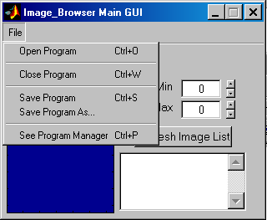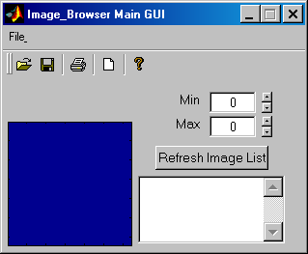

Once the program is running, it can be saved by selecting File→ Save Program As… from the menu created on the GUI. The file created will have a .pmp extension which stands for Program Manager Program. The saved version of the program can be opened using File→ Open Program.

The saved version of any program contains the following information:

- The program name, main GUI name, and the aliases and m-file names of all GUIs in the program.
- The location and visibility of all GUIs in the program.
- The values of an variables that have a flag called 'Config' in the makeGlobalCellArray param/value pairs list with the value set to 1.
- The current version of the main GUI for the program.
  - The main GUI is the GUI listed first in the call to program. Here, since there is only one GUI, it is automatically the main GUI for the program.
- The current version of the program manager.
  - 3 & 4 are used to check for compatibility of programs saved to disk when loaded at a later date.

